DEVELOP A WEB APPLICATION USING NODE-RED SERVICE DASHBOARD NODES FOR CREATING WEB U.I(WEB APP)

|  |  |
| --- | --- |
| **Team ID** | **PNT2022TMID33933** |
| **Project Name** | **Gas Leakage Monitoring and Alerting**  **System** |

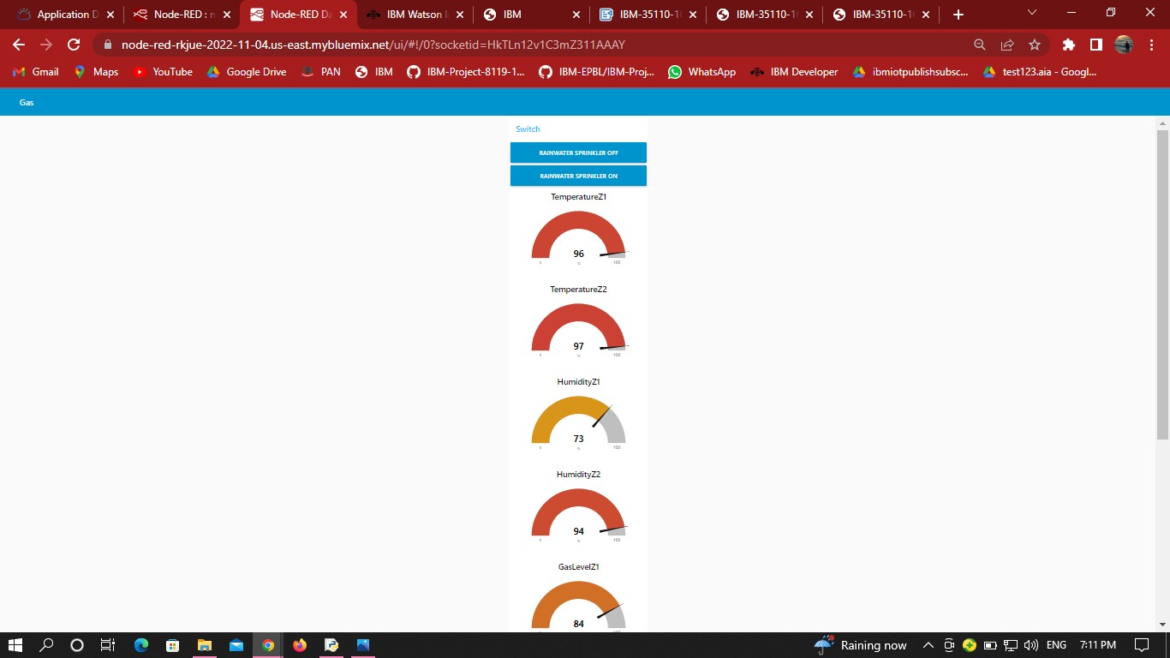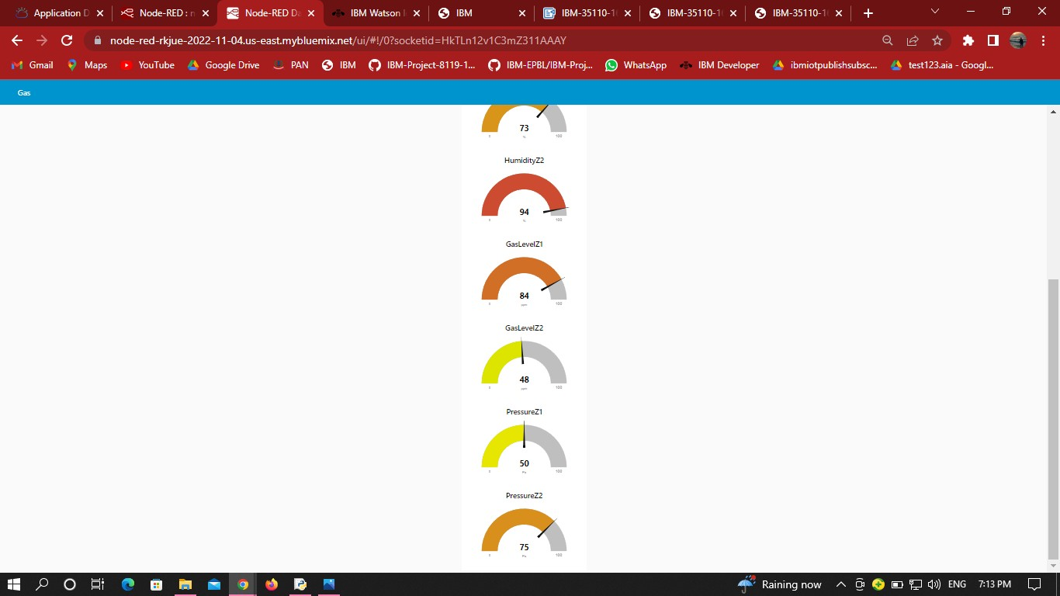WEB UI:



